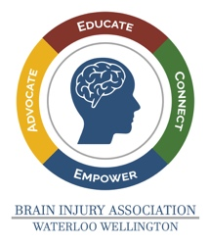 | Brain Injury Association of Waterloo-Wellington  Advocate | Educate | Connect | Empower  Email: info@biaww.com  Website: www.biaww.org  “Like” us on Facebook:  www.facebook.com/BrainInjuryAssociationWaterlooWellington/
Please provide three (3) character references. They may include co-workers, professionals, clergy, etc. They may not include relatives.

Reference #1
Name: _____________________________________________
Address: _____________________________________________
_____________________________________________
Daytime Phone: _____________________________________________
Evening Phone: _____________________________________________

Reference #2
Name: _____________________________________________
Address: _____________________________________________
_____________________________________________
Daytime Phone: _____________________________________________
Evening Phone: _____________________________________________

Reference #3
Name: _____________________________________________
Address: _____________________________________________
_____________________________________________
Daytime Phone: _____________________________________________
Evening Phone: _____________________________________________
The Brain Injury Association of Waterloo Wellington (BIAWW) has my permission to contact the above character references for the purposes of volunteering for BIAWW.

Signature ______________________________ Date _____________________

Printed Name ______________________

